71 What are the key strategies for effective problem-solving in a professional context? Please highlight the important words to the semantic meanings in every sentence using boldface fonts.

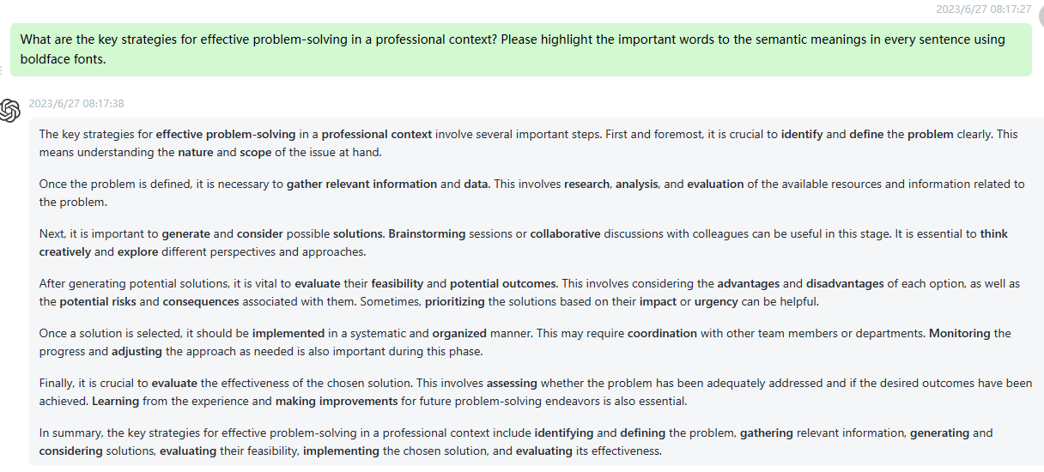

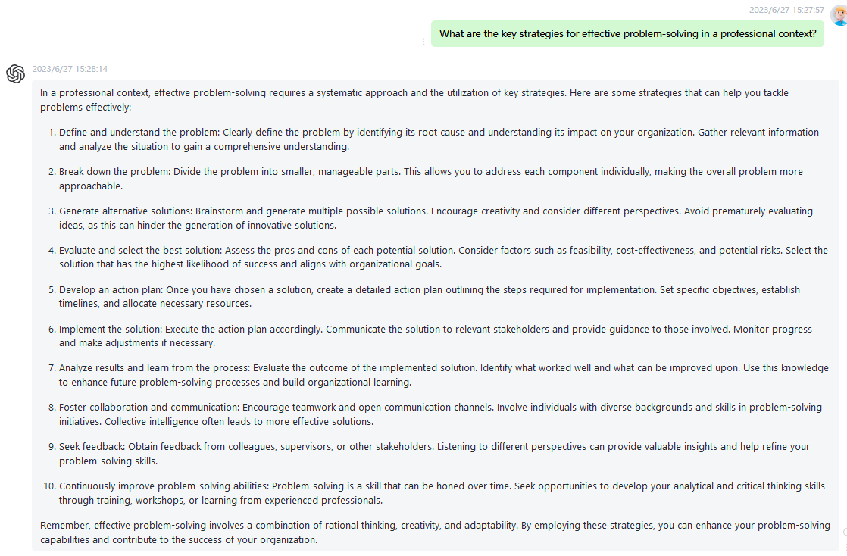

72 How can I develop my emotional intelligence and improve my interpersonal relationships? Please highlight the important words to the semantic meanings in every sentence using boldface fonts.

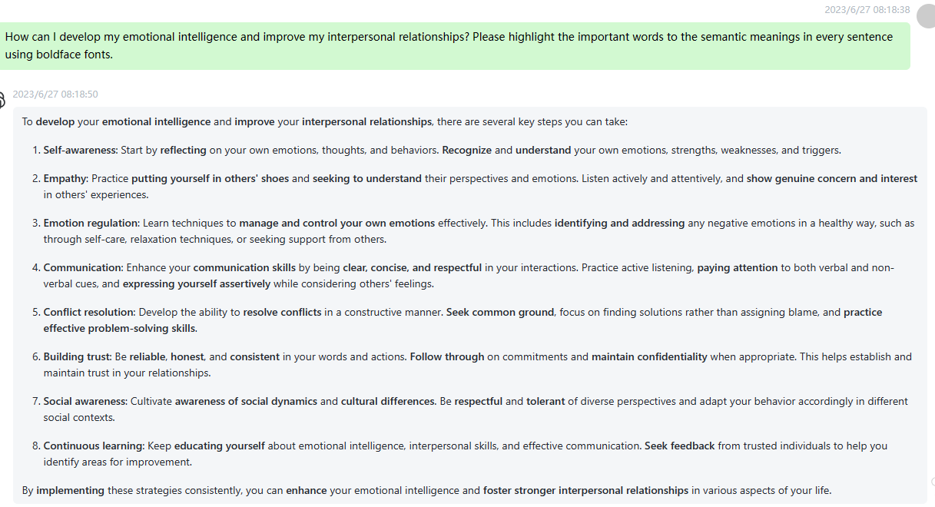

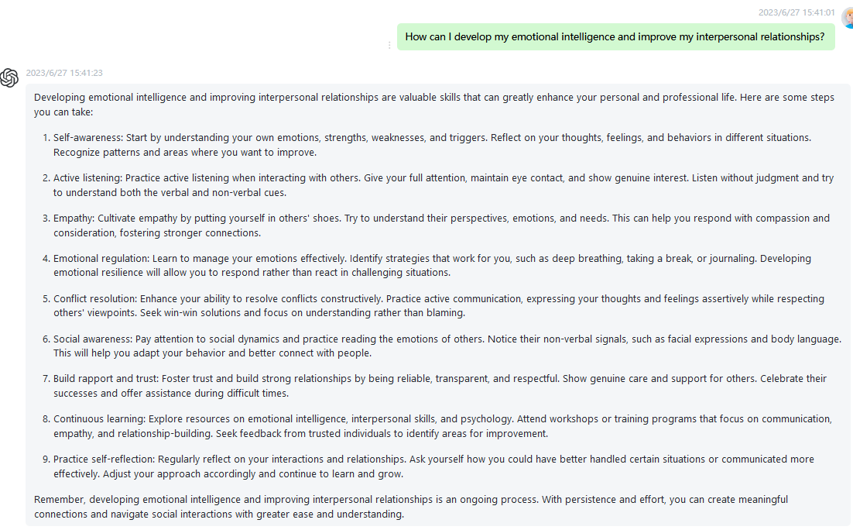

73 What are the best practices for conducting efficient and productive meetings? Please highlight the important words to the semantic meanings in every sentence using boldface fonts.

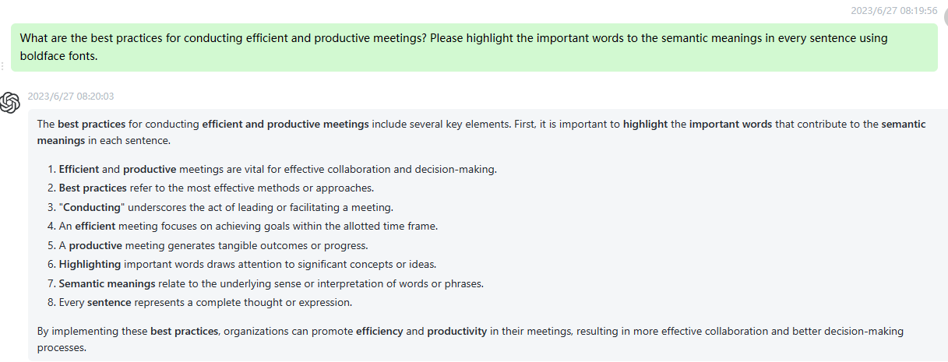

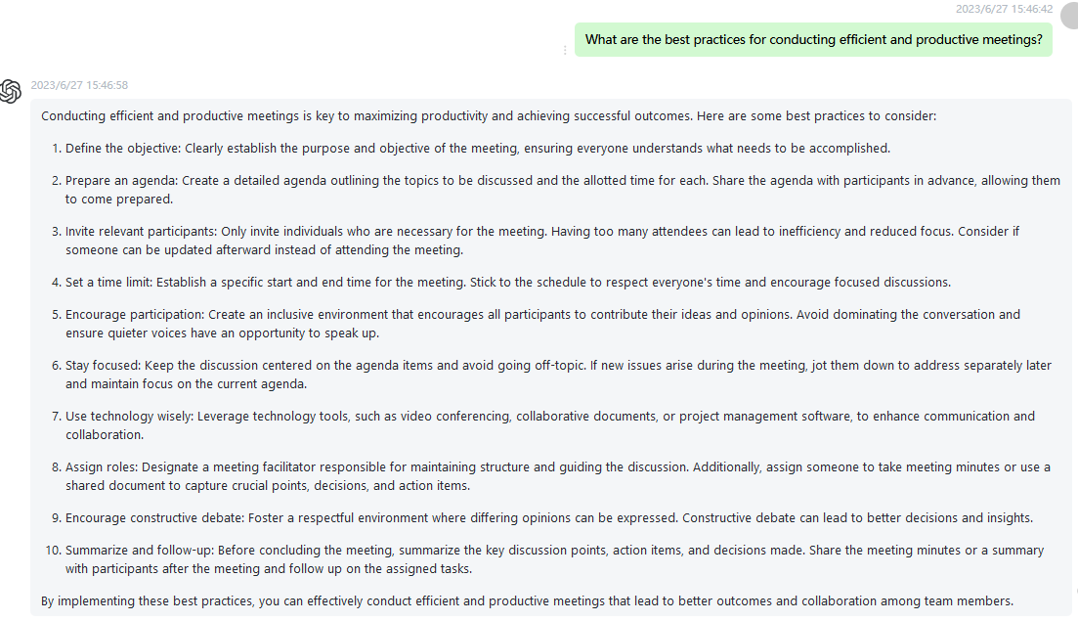

74 How can I foster a culture of innovation within my organization? Please highlight the important words to the semantic meanings in every sentence using boldface fonts.

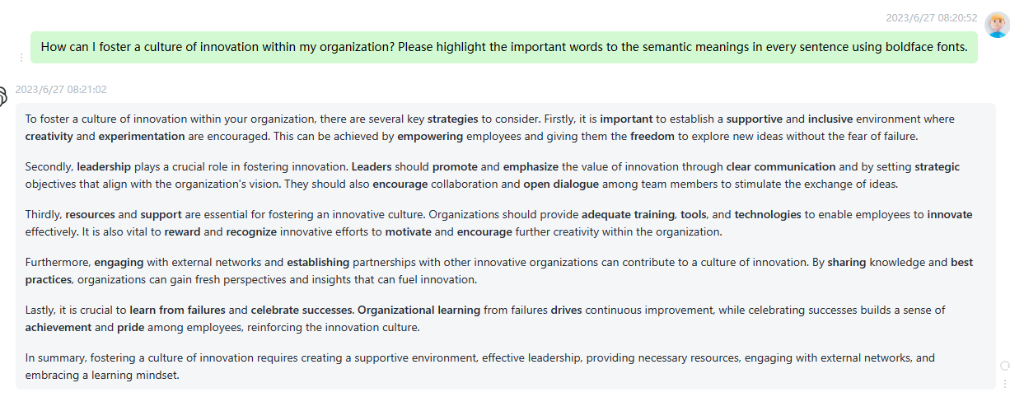

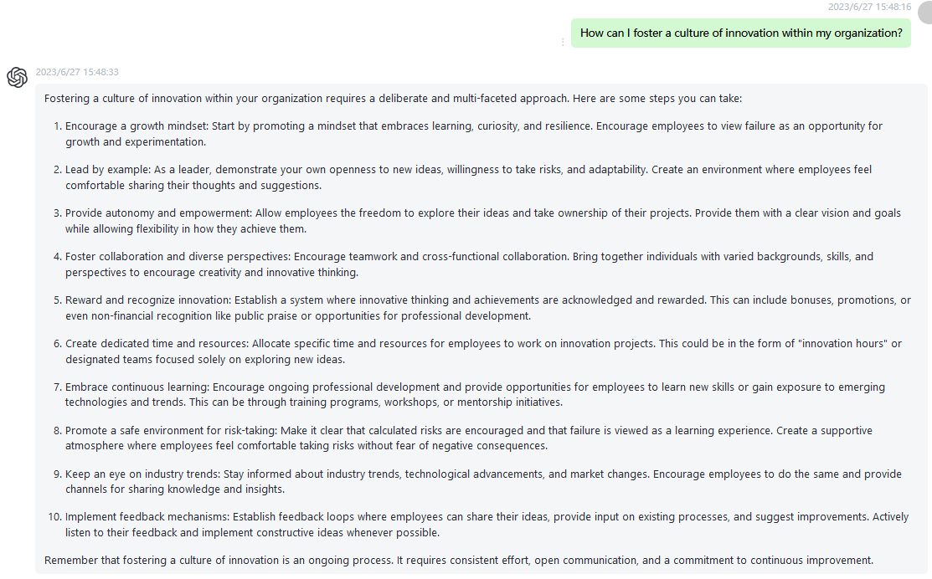

75 What are the essential skills for successful project management? Please highlight the important words to the semantic meanings in every sentence using boldface fonts.

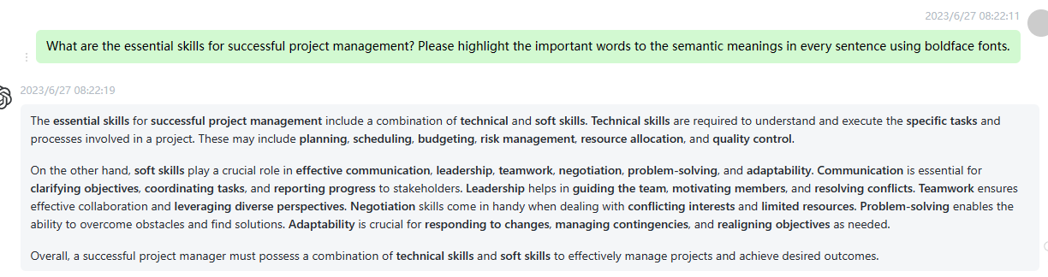

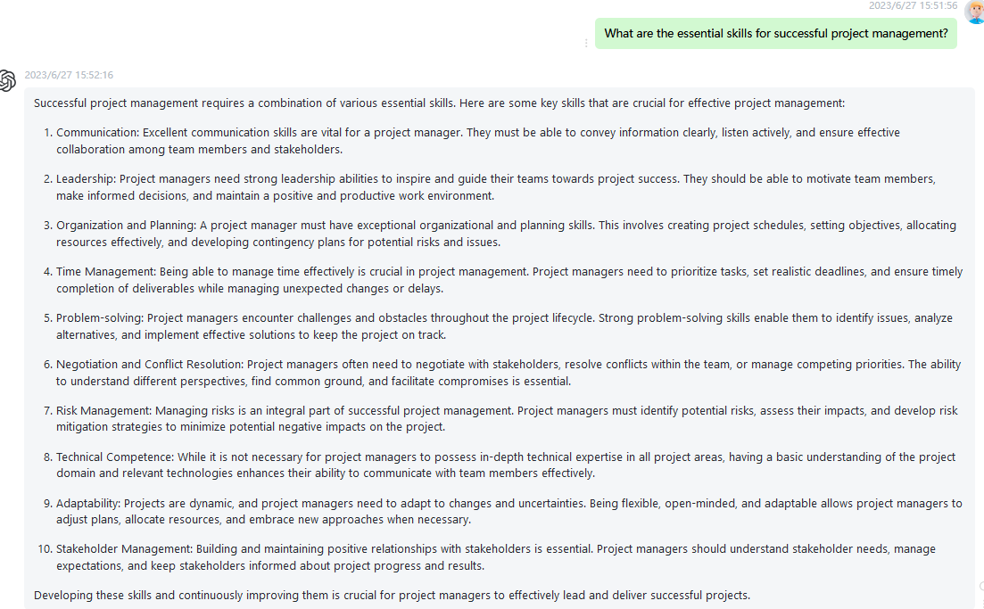

76 How can I build resilience and manage stress in high-pressure situations? Please highlight the important words to the semantic meanings in every sentence using boldface fonts.

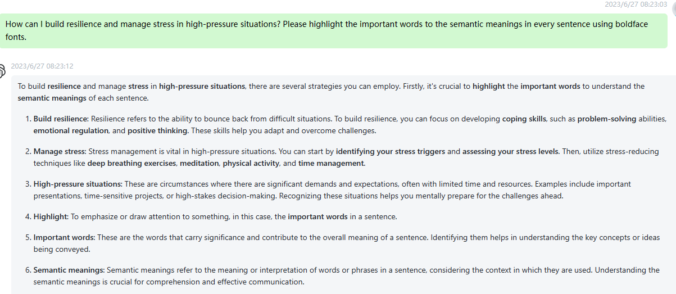

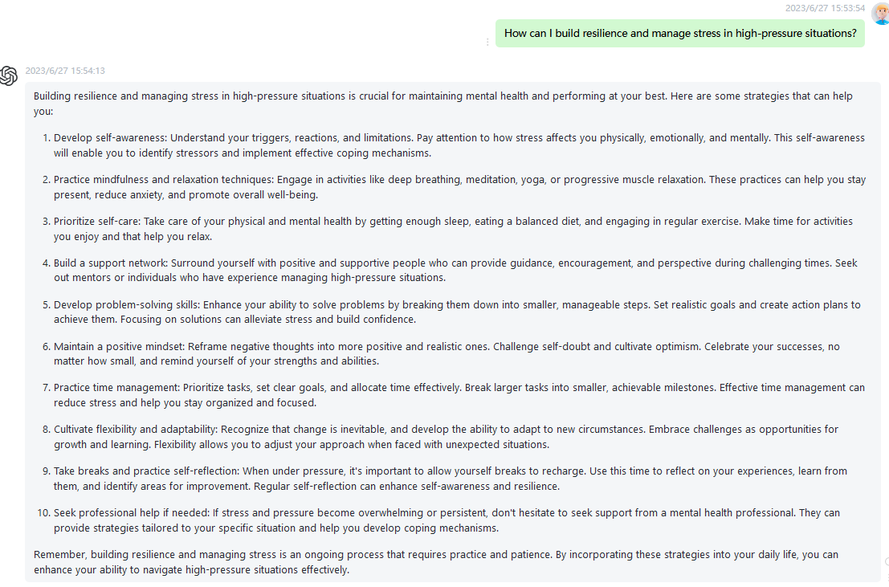

77 What are the emerging trends in digital marketing and how can I leverage them for business growth? Please highlight the important words to the semantic meanings in every sentence using boldface fonts.

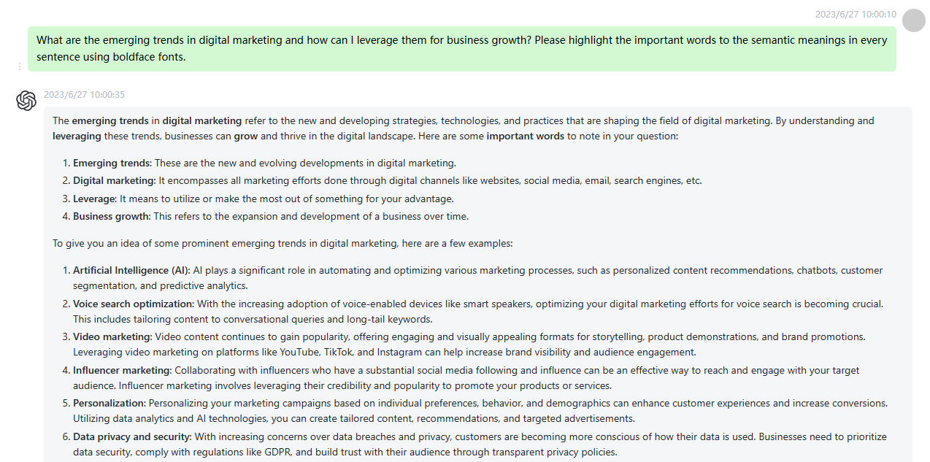

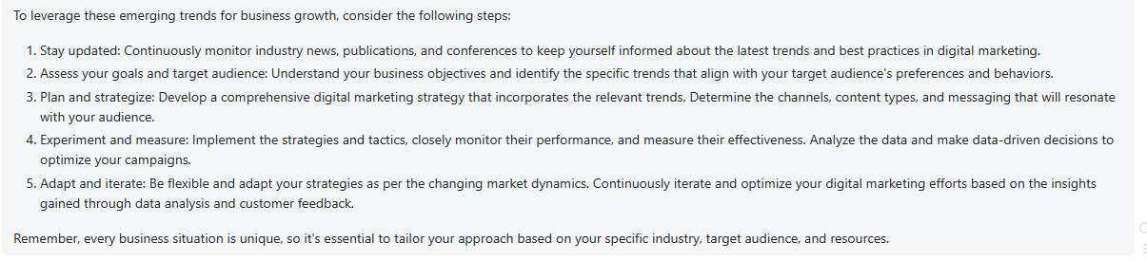

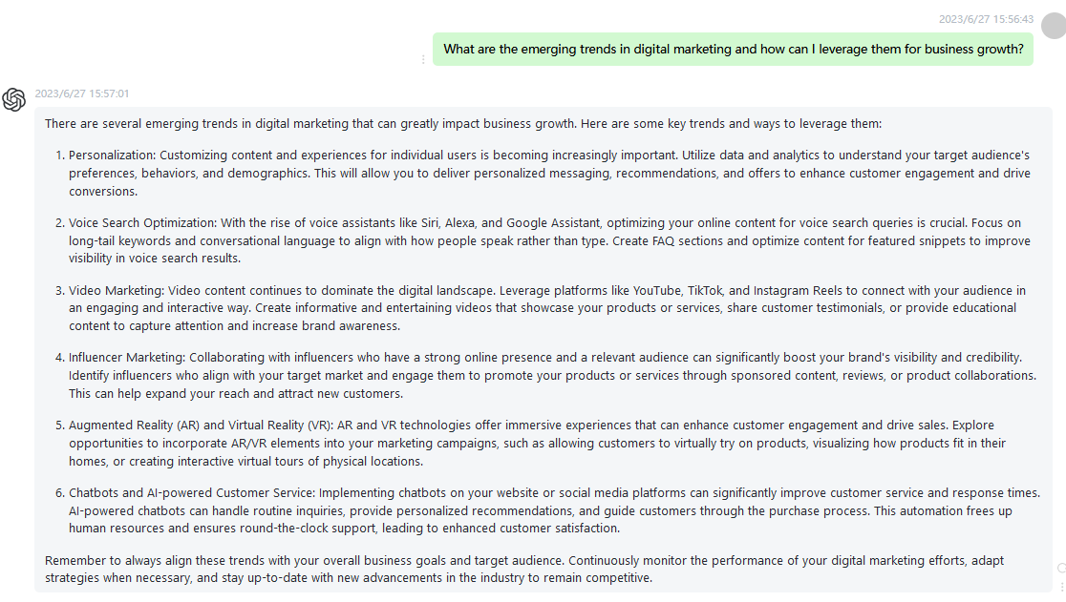

78 How can I enhance my creativity and generate innovative ideas? Please highlight the important words to the semantic meanings in every sentence using boldface fonts.

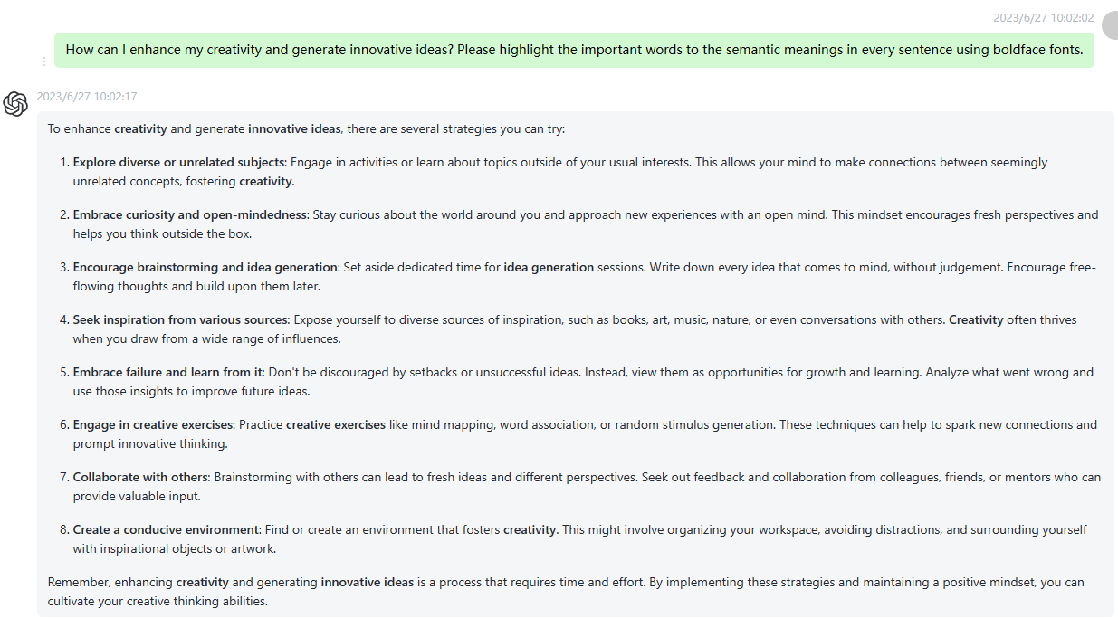

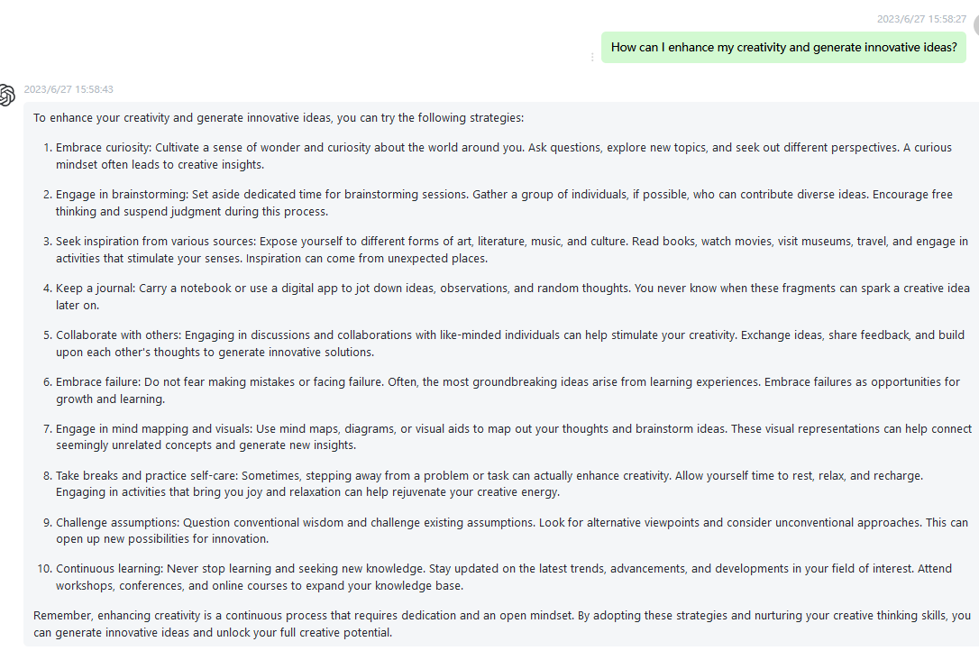

79 What are the ethical considerations in data privacy and cybersecurity? Please highlight the important words to the semantic meanings in every sentence using boldface fonts.

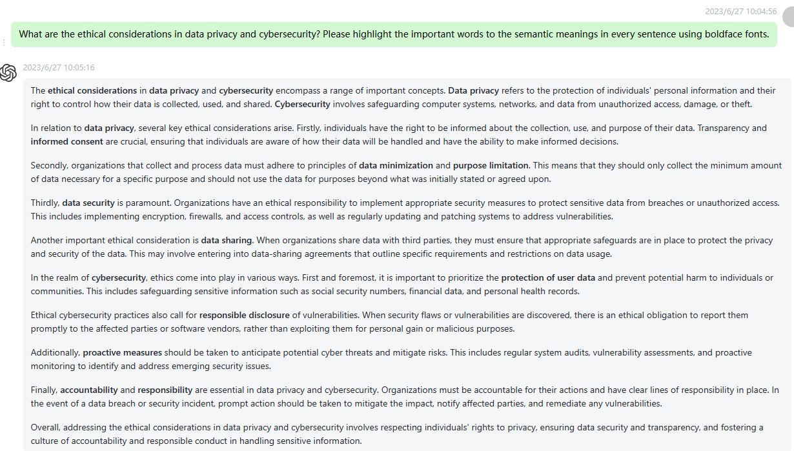

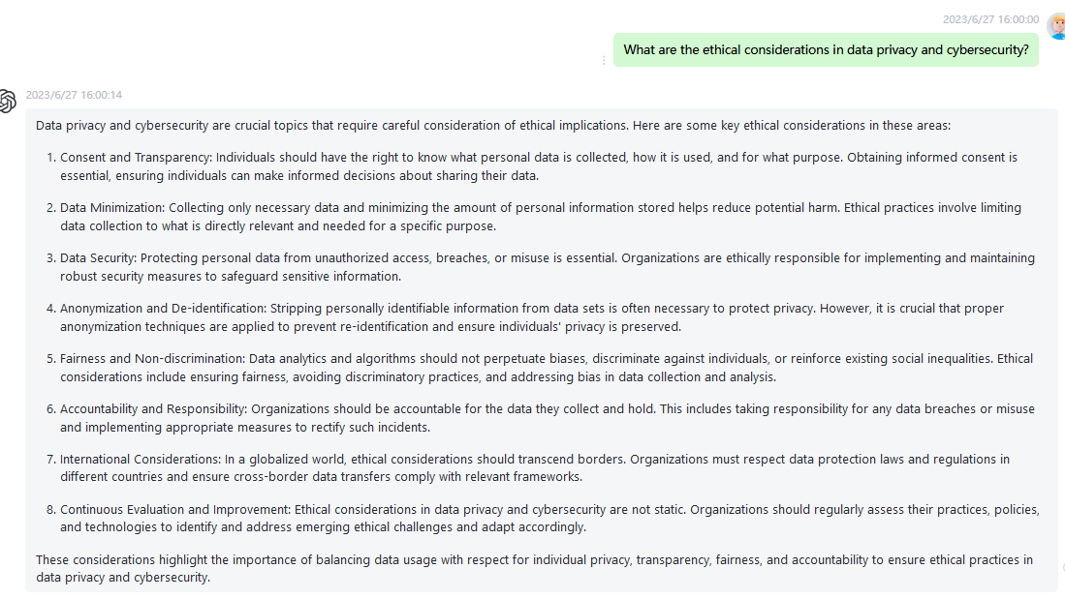

80 How can I develop effective negotiation skills and achieve win-win outcomes? Please highlight the important words to the semantic meanings in every sentence using boldface fonts.

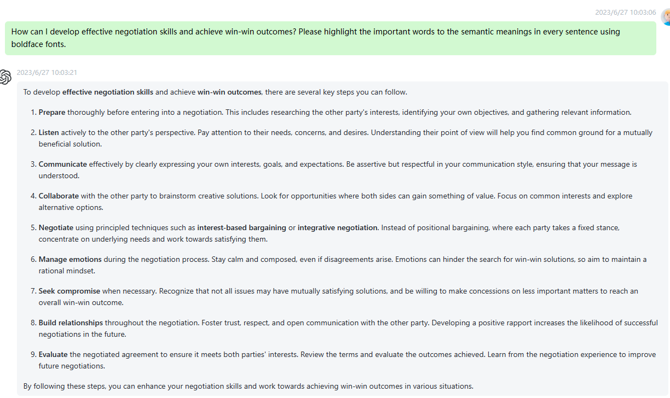

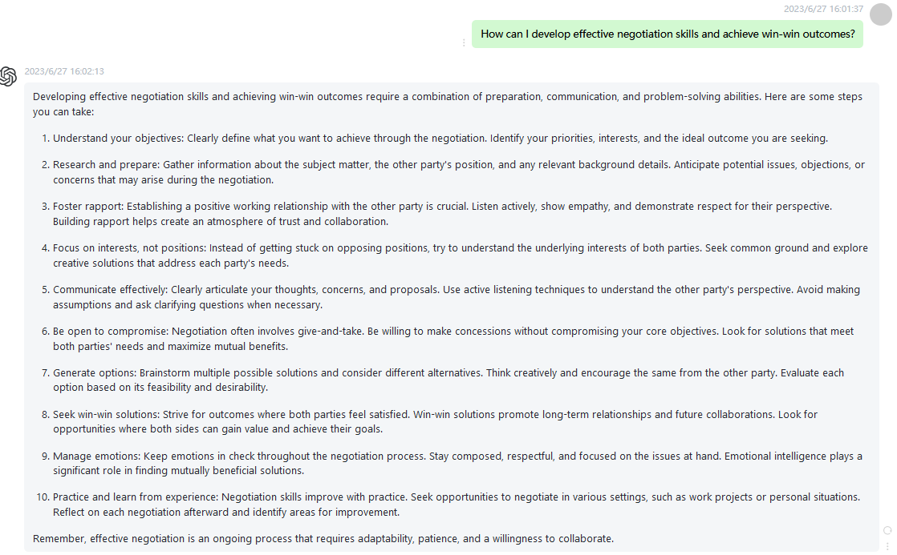

81 What are the key elements of effective customer relationship management? Please highlight the important words to the semantic meanings in every sentence using boldface fonts.

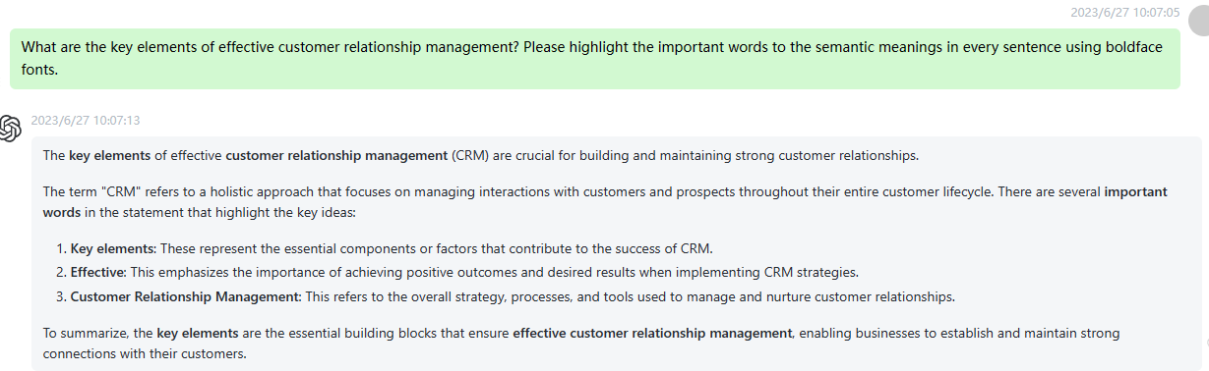

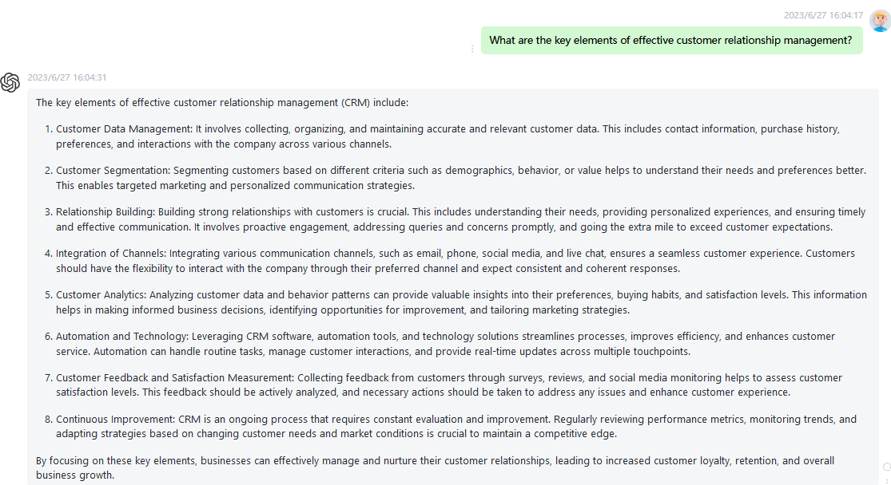

82 How can I improve my financial literacy and make smart investment decisions? Please highlight the important words to the semantic meanings in every sentence using boldface fonts.

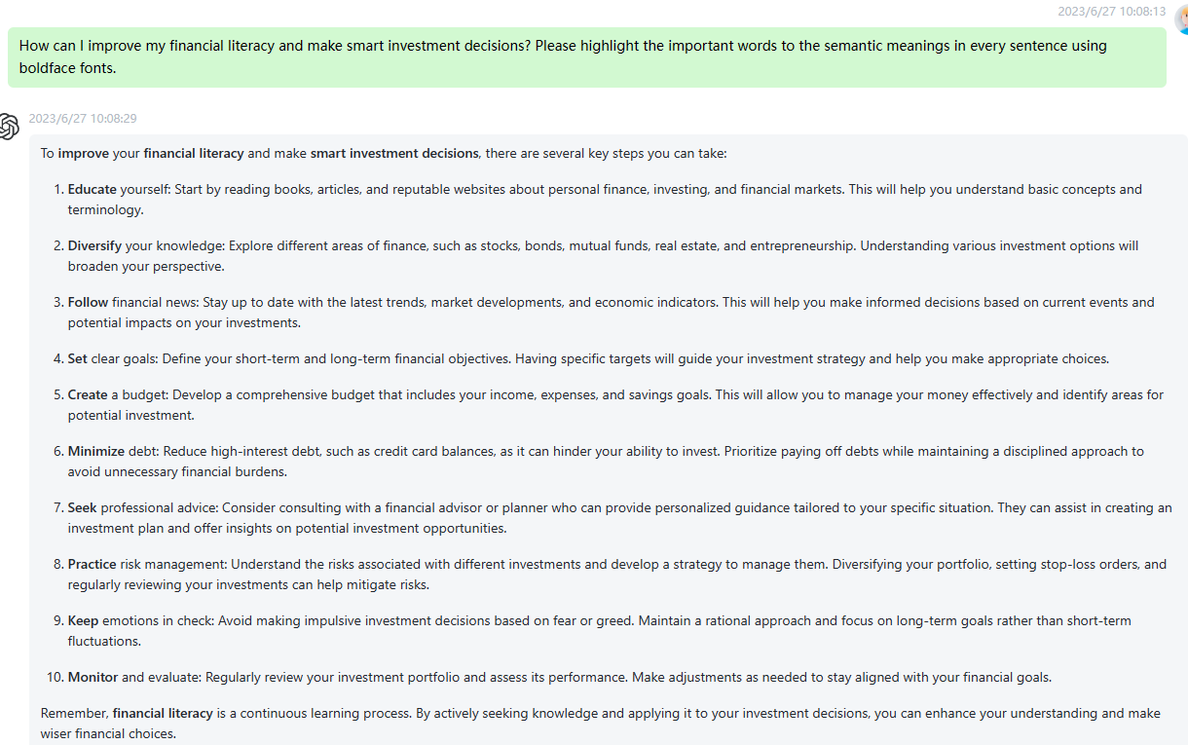

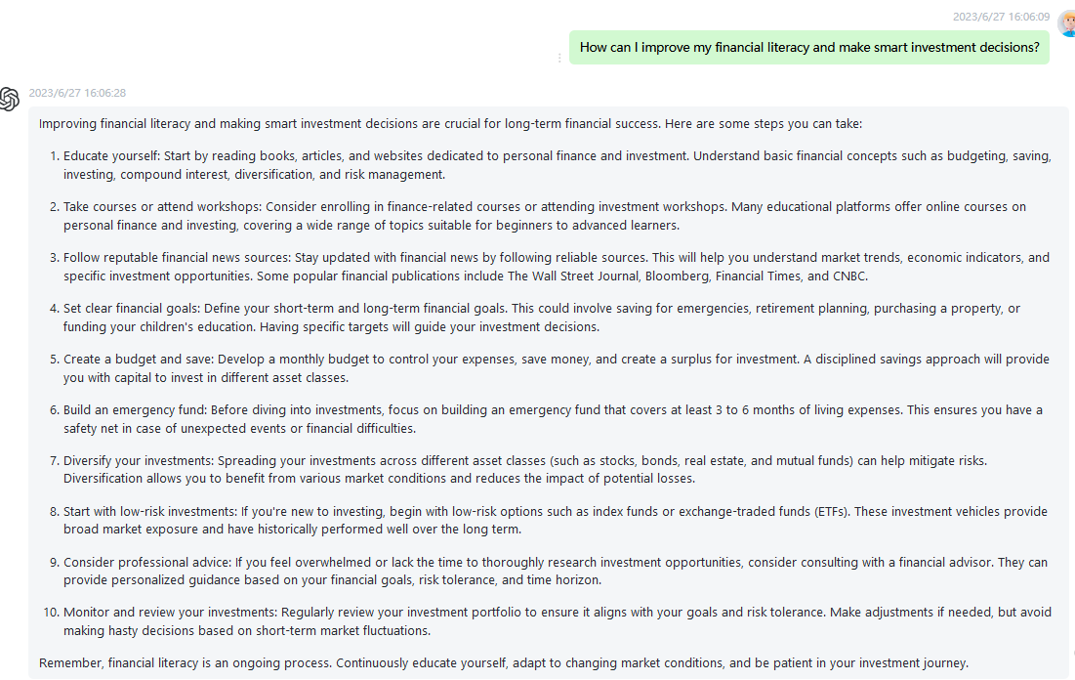

83 What are the best strategies for effective conflict resolution in the workplace? Please highlight the important words to the semantic meanings in every sentence using boldface fonts.

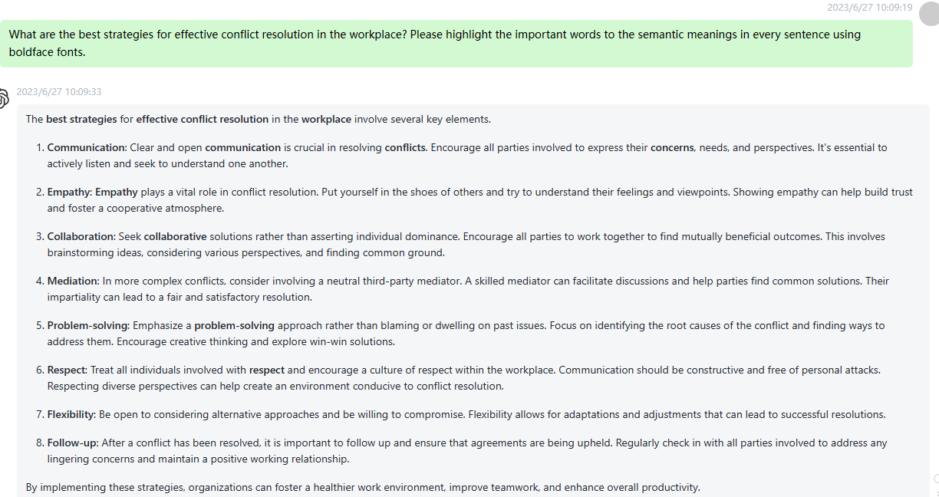

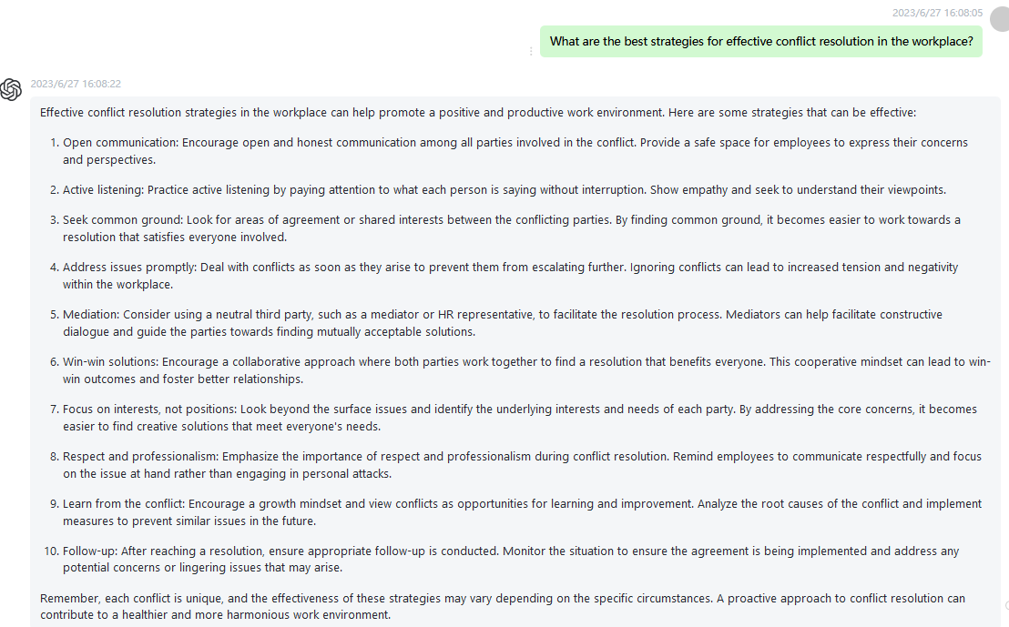

84 How can I cultivate a positive and inclusive company culture? Please highlight the important words to the semantic meanings in every sentence using boldface fonts.

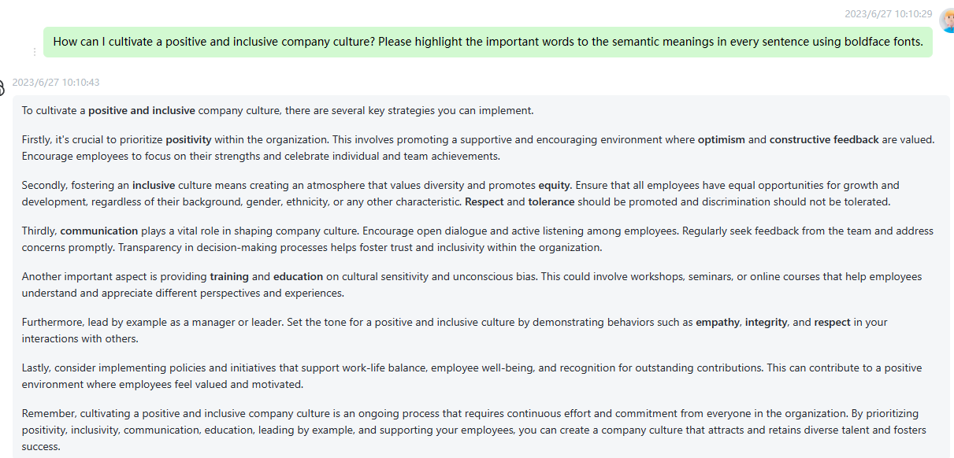

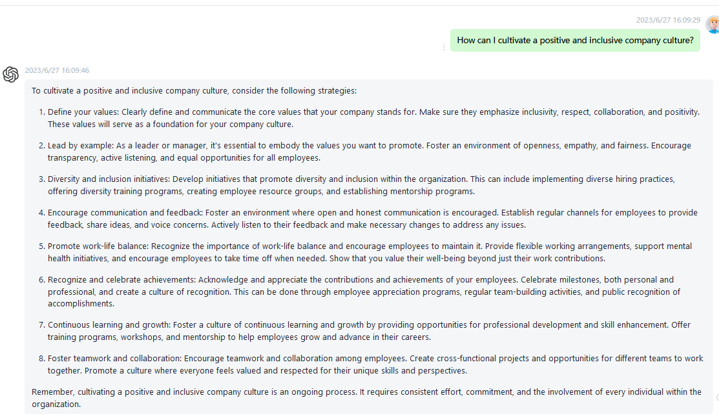

85 What are the steps to successful strategic planning and implementation? Please highlight the important words to the semantic meanings in every sentence using boldface fonts.

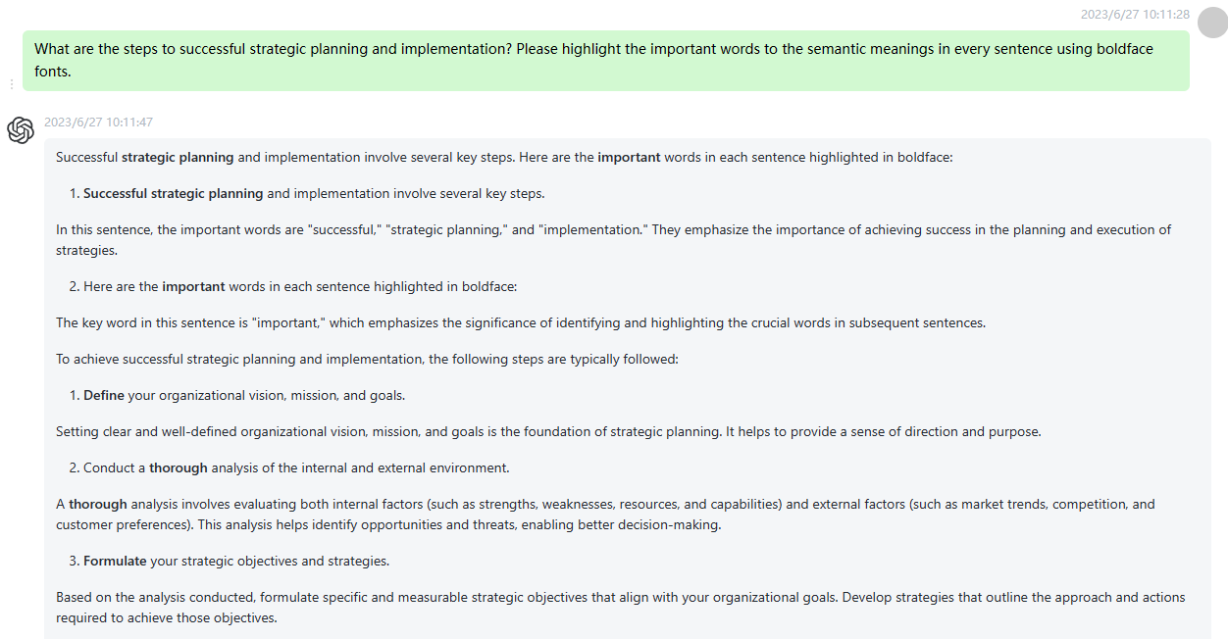

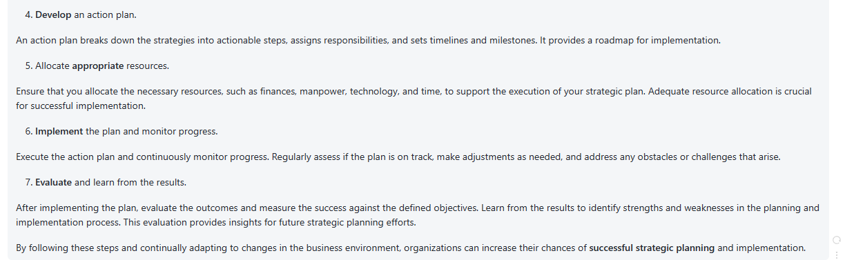

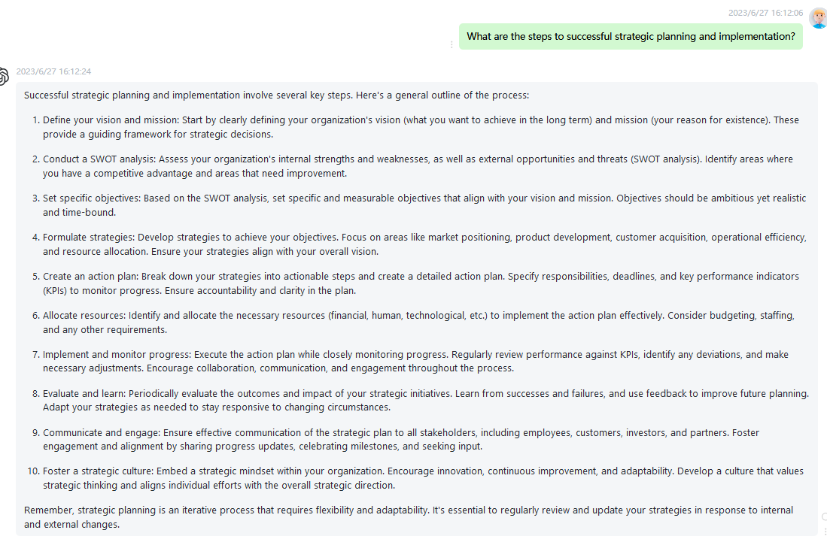

86 How can I leverage social media platforms for personal branding and professional networking? Please highlight the important words to the semantic meanings in every sentence using boldface fonts.

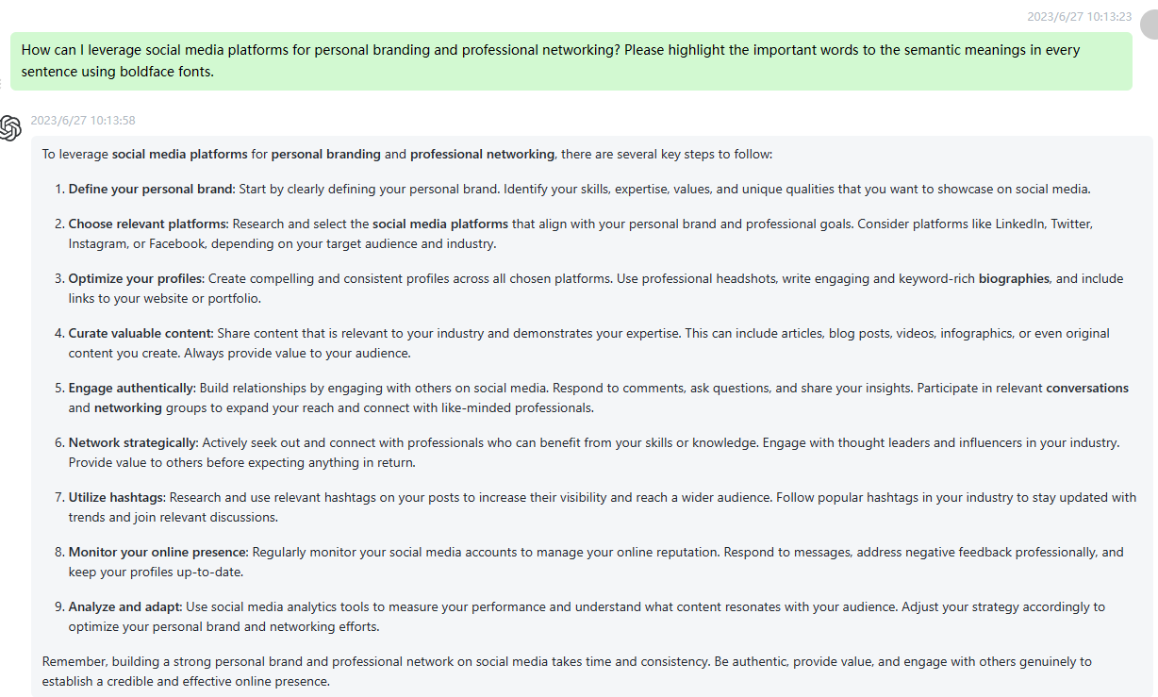

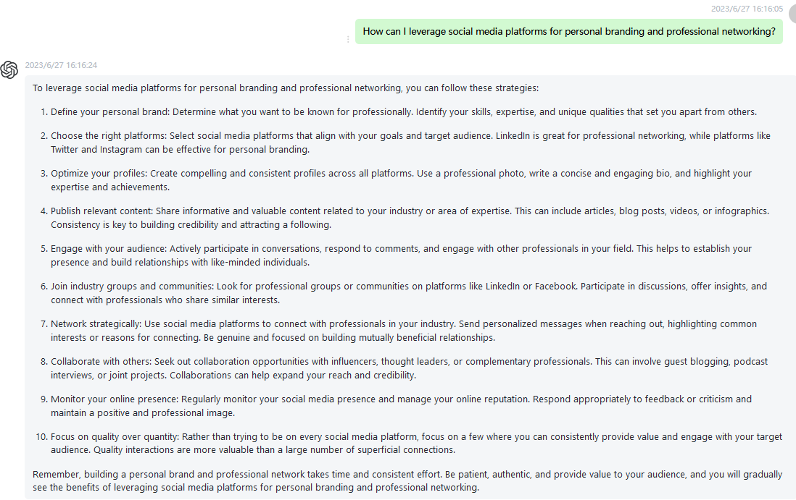

87 What are the key factors in building and leading a high-performing team? Please highlight the important words to the semantic meanings in every sentence using boldface fonts.

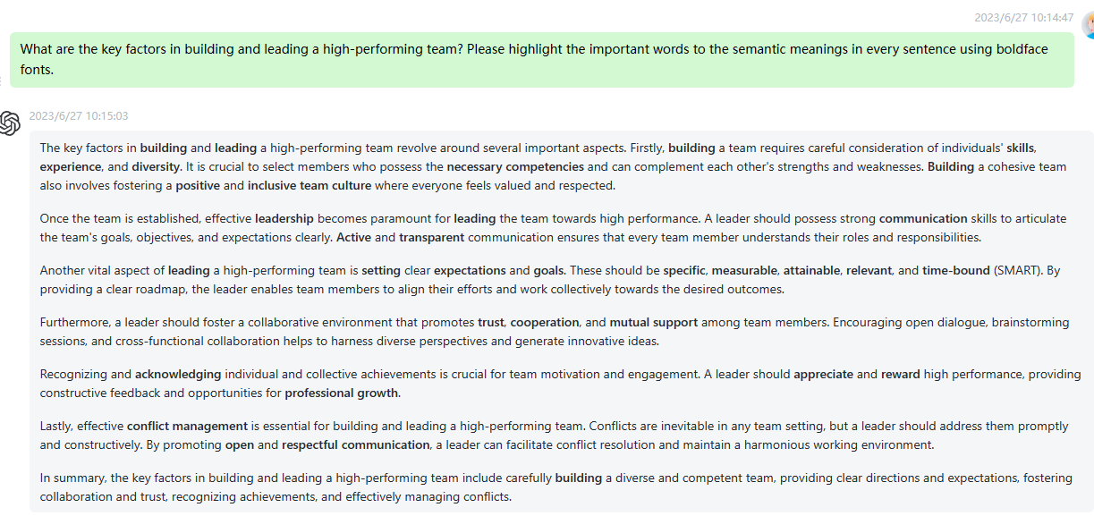

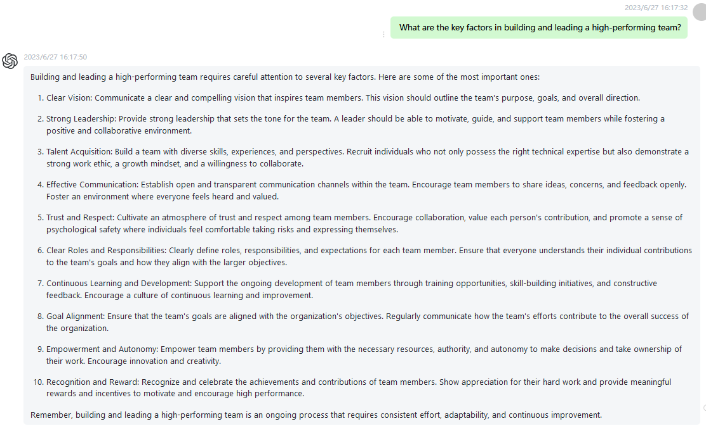

88 How can I develop my analytical thinking skills for data-driven decision-making? Please highlight the important words to the semantic meanings in every sentence using boldface fonts.

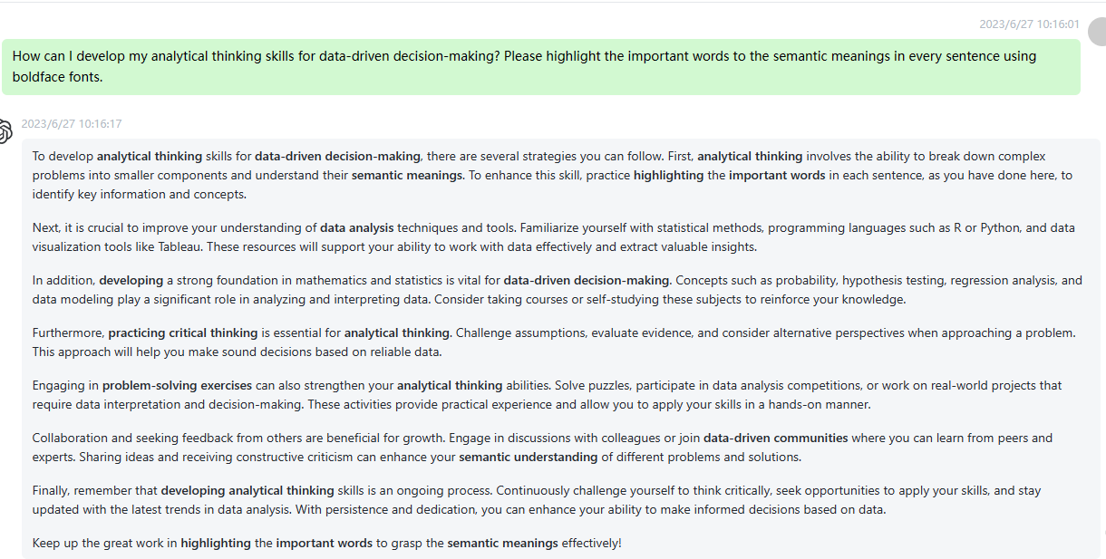

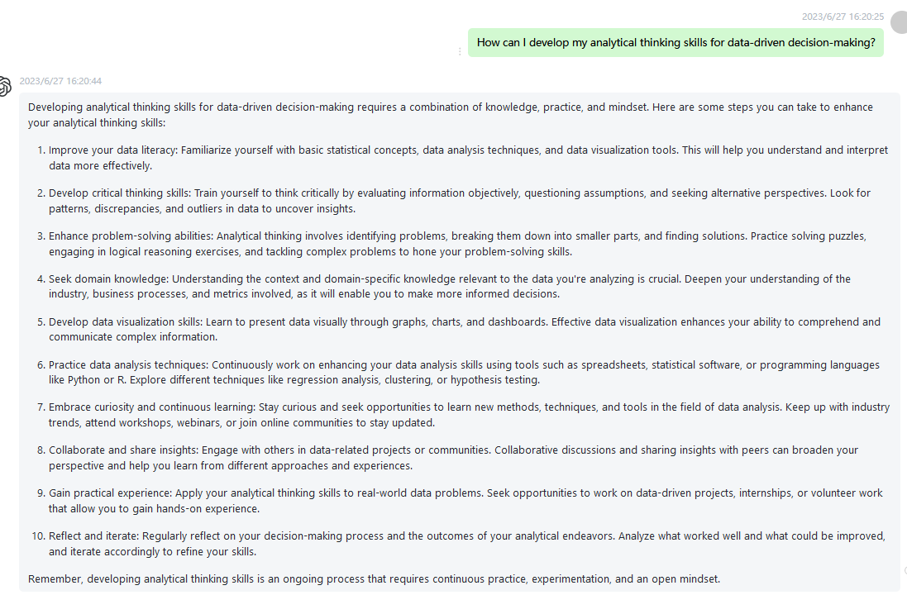

89 What are the strategies for effective change management in organizations? Please highlight the important words to the semantic meanings in every sentence using boldface fonts.

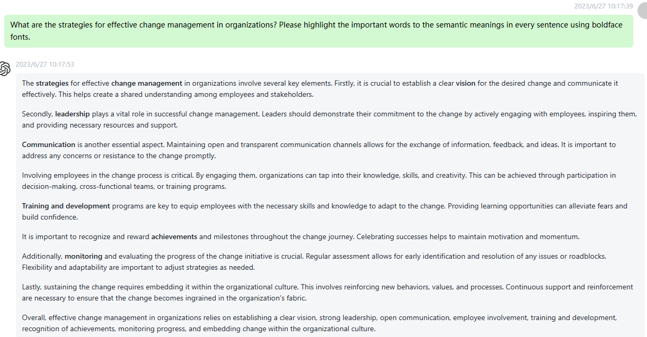

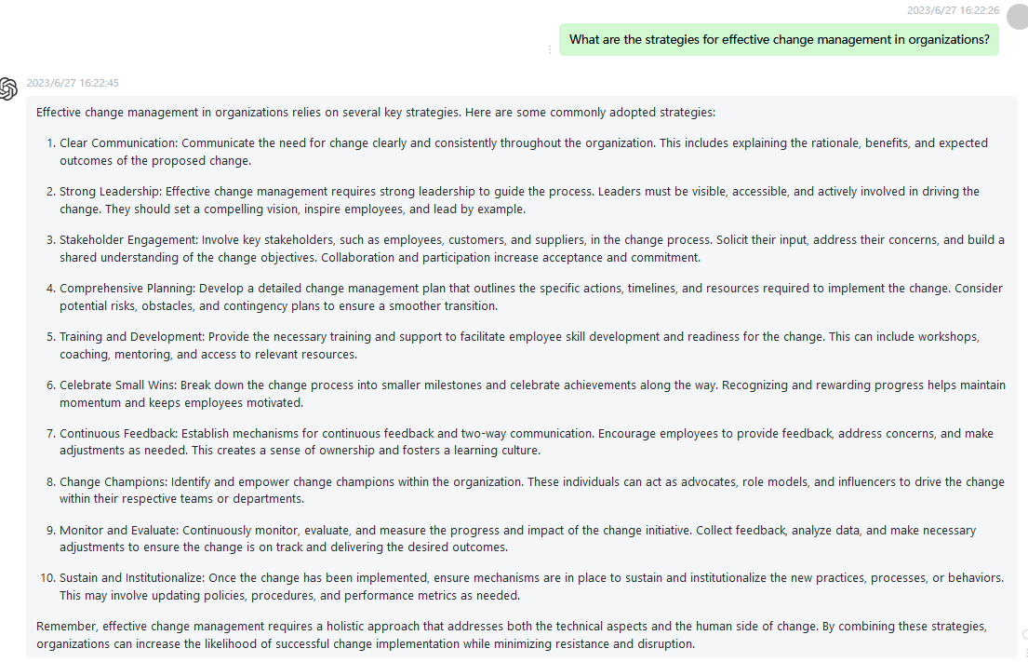

90 How can I stay updated with the latest industry trends and developments? Please highlight the important words to the semantic meanings in every sentence using boldface fonts.

